

**KENYA METHODIST UNIVERSITY**

**SCHOOL OF SCIENCE AND TECHNOLOGY**

**DEPARTMENT OF PURE AND APPLIED SCIENCE**

**RESEACH PROJECT PROPOSAL**

**COMP 401**

**TITLE: NORTH STAR COOLING SYSTEM MOBILE APPLICATION SYSTEM**

**PRESENTED BY: ADUDA SHEM IMMANUEL ODHIAMBO**

**REG No: MAC-1-8943-2/2019**

# ABSTRACT

North Star cooling system Mobile application is a convenient and easy method that users will use in ordering for specific goods and services related to cooling systems, get an overview of the finished and ongoing projects and also follow up on their specific orders. These services include both small and large scale whereas in large scale, the company deals with installation of cooling systems in organizations like schools, heath cares, hotels and also industries, whereas in small scale, they deal with household installation and maintenance of the cooling systems.

# DECLARATION

I the undersigned solemnly declare that this research project, is based on my own work carried out during the course of our study. No part of this research may be reproduced without the prior permission the other and /or KEMU.

**NAME OF CANDIDATE:** ………………………………………………

**SIGNATURE**: ………………………..

**DATE**: ……………………………

**DEPARTMENT**: Pure and applied science

**UNIVERSITY**: Kenya Methodist University

## DECLARATION BY THE SUPERVISOR (S)

This research proposal have been submitted for examination with our approval as the university

Supervisor.

**NAME OF SUPERVISOR**: …………………………………

**SIGNATURE:** …………………………

**DATE**: ………………………….

**DEPARTMENT** …………………………………

# **TABLE OF CONTENTS**

**RESEACH PROJECT PROPOSAL** i

ABSTRACT ii

DECLARATION iii

DECLARATION BY THE SUPERVISOR (S) iii

**TABLE OF CONTENTS** iv

**CHAPTER ONE** 1

**INTRODUCTION** 1

**1.1 Background Study** 1

**1.2 PROBLEM STATEMENT** 2

**1.3 JUSTIFICATION** 3

**1.4 OBJECTIVES** 3

**a)** **General Objective** 3

**b)** **Specific Objectives** 3

**1.5 SCOPE OF THE STUDY** 4

**CHAPTER TWO** 7

**LITERATURE REVIEW** 7

**CHAPTER THREE** 9

**RESEARCH METHODOLOGY** 9

**Feasibility study** 9

**Technical feasibility** 9

**Social feasibility** 9

**Economic feasibility** 9

**Operational feasibility** 10

**Legal and contractual feasibility** 10

**SYSTEM ANALYSIS** 10

**System requirements** 10

**User requirements** 10

**SYSTEM DESIGN** 10

**SYSTEM DEVELOPMENT** 10

**TESTING AND INTERGRATION** 10

**SYSTEM RESOURCES** 11

**PROJECT BUDGET** 11

**PROJECT SCHEDULE** 12

**CHAPTER 4** 13

**4.0 RESULTS** 13

**4.1 User Interface** 13

**4.1.1 Admin Interface** 13

**4.1.2 Admin dashboard** 14

**4.2 User module** 15

**4.2.1 Client interface** 16

**4.2.2 Supplier Interface** 17

**4.2.3 Cashier Interface** 18

**4.2.3 Stock manager Interface** 19

**4.2.3 Engineer Interface** 21

**4.2.4 Technician Interface** 22

**4.3 Help and FAQs module** 23

**4.3 About us module** 24

**4.4 Database module** 25

**5.0 Conclusion and Recommendations** 26

**5.1 Conclusions** 26

**5.2 Recommendation** 26

References 27

# **CHAPTER ONE**

## **INTRODUCTION**

### **1.1 Background Study**

North Star cooling systems LTD is a Nairobi based company in Kenya developed in the year 2005 by **Mr. Kishore Reddy Palappa** that specializes in the Design, Supply, Installation, repair, Maintenance and Optimization of mission critical HVAC (8k uh ventilation and air conditioning) and refrigeration systems.

Their services include large commercial A/C system, chiller units, Rooftop package units, and cooling management systems. The company handles various projects from domestic to large commercial products of different sizes and different sectors like healthcare, entertainment, government and more by studying the customer’s needs and creating customized solutions based on the customer’s problems and needs. They have partnered with various reputable companies such as Toshiba, Carrier and Siemens. They have completed major projects around the country including; installation of Chiller Works at Two Rivers Retails, Entertainment and Lifestyle Project (Carrefour & Vox Cinema, Magic Planet) for the well. And are also running a major Proposed Head Office Development Fit-out for AAA Growers**.**

North Star cooling systems is one of the industries that has greatly been affected by the COVID 19 pandemic in that they are based in Nairobi and the services they offer have only been limited within their region due to the imposed initiatives by the governments, an example is the restriction of movement between one county to another. Clients have been facing challenges in acquiring their services because of the limited freedom to visit their workshop physically and in turn may end up ordering for services and gadgets that don’t much their preferences. This leads to customer dissatisfaction.

Users are often dissatisfied with the results of common search engines when looking for specific cooling systems and the skilled workmen to repair and maintain their installed systems. This is because, information about cooling technologies rarely meet the needs of their intended applications. Developing a mobile application for North Star cooling system will increase the speed and efficiency in that customers will be able to buy their services and cooling systems with ease regardless of their present location and also get proper recommendations from the experts. Large scale clients will be able to review both the recommendation and models of their past projects enabling them to get an idea of the systems they will require in their organizations. Maintenance and repair will be easily done because the clients will be able to contact the organization with their specific problems. The payment will be easily made with an advantage of tracking and keeping record of the payment done to enable ease in service. It will boost their competitive advantage in that the users can easily buy their services online because of the ease in accessibility.

## **1.2 PROBLEM STATEMENT**

Ideally, the customers should be able to use their android devices to order services and cooling devices from the company while at different areas in the country with ease. The customer should be able to view the related cooling systems, services and past successful projects as well as their prices. It will make it possible for the customer to see the availability of the products and services. Payments can be done via the app also.

Currently, most of the company’s processes and procedures are done manually. These processes include; contacting the organization and requesting their services via online form or making a phone call to inquire about the availability of the products and services. The organization will then review the user needs and later contact the client by phone or email with a meeting schedule depending on the availability of the service. After the project is approved, a project manager is appointed who will conduct and supervise the project until its completion. The project manager and his team design a work plan awaiting approval by the company, after the approval they conduct site mobilization and procuring items that they are going to use in conducting the work then system installation is conducted and tested. If the system is working, it is commissioned and handed over to the client. In case of any system or maintenance the client contacts the organization, which will assign foremen and technicians based on the problem and specialization to conduct the repair and maintenance. If the service or cooling system is available, then the user is sent to make a payment before they are served. The payment is then processed by a cashier and the system is transferred to the client. The services can be paid before or after completion depending on the agreed terms. In case the service or cooling system is not available, then the client is advised to wait before being contacted or referred to another organization.

The development of the mobile application will ease access to the goods and services in that the customer will be able to view the name, pictures and a brief description of the items as well as their price which will save on time spent when a customer calls without knowing the name of the item, inquiring a brief description and sometimes ordering the wrong service or product. And also, it will create a work friendly environment in that misunderstandings between the client and employees will be reduced. The customers will be able to make payments easily and a report generated to help them record their transaction. The large-scale clients will be able to see the finished projects and reviews from other experienced users who left their feedbacks and recommendations after receiving the available services.

## **1.3 JUSTIFICATION**

The proposed mobile application system will be designed to automate all North Star cooling systems processes, thereby eliminating the manual process. The users to benefit from this system are clients who want to purchase or access services like repair and maintenance of cooling systems and also large organizations like hospitals, banks, schools, and hotels that require installation, repair and maintenance of the related HVAC and refrigeration systems.

The mobile application will enable the users to view the finished and the ongoing projects being undertaken before deciding on the design of their specific project. Users will be able to leave and view feedbacks after services and before ordering their services.

Customer client relationship will be upheld in that there will be minimum misunderstanding caused during service inquiry and misinformation between the clients and the workers of the company. Immediate repair services can also be ordered.

## **1.4 OBJECTIVES**

### **General Objective**

* To develop mobile application for North Star cooling systems LTD.

### **Specific Objectives**

* To develop a database for North Star cooling systems.
* To create an administration web interface.
* To create a mobile application for front end users for the company.
* To create a customer module for North Star cooling systems.

## **1.5 SCOPE OF THE STUDY**

The proposed mobile application system will target both large scale and individual consumers interested in HVAC and refrigeration system. The users of the mobile application are as follows;

* Administrator
* Stock manager
* Customer
* Finance manager
* Project manager
* Site engineer
* Refrigerant technician
* Duct technician
* Supplier

Some of the mathematical operation that the system has include;

* Calculation of the stock in and stock out
* Calculating the amount of money to be paid per service and item
* Calculate amount of money to be paid to the suppliers

The following modules will be covered;

#### Database module

This module will be a central location where all the data related to the company and the users will be stored for ease of access and update.

#### Administrator module

The administrator will be in charge of everything and will be able to;

* Access all the modules
* Access customer feedbacks and recommendations’
* Approve transactions
* Activate and deactivate the employee accounts

#### Employee module

This module will include the; project manager, engineers, technician and other employees. Each project manager will be assigned an engineer and other employees who will work under him/her.

The employees will be able to;

* Log in to the system
* View the projects assigned to them
* Leave a feedback
* Project managers will be able to view the customer requests serviced to them

#### Customer module

The customers will be able to;

* Register their account
* Log in to the system
* Order their services or related HVAC and refrigeration system
* Make payment for the ordered item or service
* Give feedback

#### Inventory Management/Stock module

This module allows the company to keep track of the stock available.

1. Finance module

This module will hold all the financial records and transactions about the organization.

1. Site engineer module

This module will hold information of the engineers with their respective proposed, ongoing and complete projects.

1. Supplier module

This module will hold the details of the suppliers and the respective goods the supply to the company.

#### Help module

This module is aimed at helping the users on how to use and navigate themselves around the system.

#### Search module

This module will help the users to easily search and locate learning materials and also specific instructors as per their option.

#### Feedback module

This module will aid users in giving any feedback while using the system.

#### Report Module

This module will help in generating receipts of the company’s finances.

#### Project module

This module shows the previous projects that have been successfully completed and also the projects that are currently in progress.

1. *About us Module*

This module will contain a brief information about the organization.

# **CHAPTER TWO**

## **LITERATURE REVIEW**

According to (Jamsheer, 2019 pg.156) e-commerce is the usage of telecommunication networks to automate business relations and workflow. On the other hand, Moreover, (Rose et al., 2019) contends that e-commerce refers to the exchanging organization data, preserving business relations, and conducting operational transactions via telecommunication systems. Ultimately, (Abdullah et al., 2021) characterizes e-commerce as utilizing computer, internet, and shared software technology to exchange merchandise descriptions and illustrations; offers and procurement details; as well as other information needed to be conversed to consumers, providers, staffs, or the community.

Increasing digitalization and the emergence of the Internet of Things have fostered growing interest in smart services in recent years (Georgakopoulos and Jayaraman, [2016](https://link.springer.com/article/10.1007/s12525-019-00328-z#ref-CR42)) Smart services are characterized by the fact that the service provider and the customer interact to create value. This process is called value co-creation (Gavrilova and Kokoulina, [2015](https://link.springer.com/article/10.1007/s12525-019-00328-z#ref-CR41)) and enables service providers to continuously adjust to a customer’s individual and constantly changing needs . Customers are supported, and new business models are realized via smart services.

The number of publications that have focused on smart services has greatly increased in recent years. Although these publications have answered many relevant research questions, none have yet articulated a systematic and comprehensive research agenda for smart services. Systematic insights in different topics help to provide a broader view on the subject (Kamp et al. [2016](https://link.springer.com/article/10.1007/s12525-019-00328-z#ref-CR52)). Therefore, the objective of the article is to present a holistic overview of past research and opportunities for further research in the field of smart services.

Last-mile delivery has become a critical source for market differentiation, motivating retailers to invest in a myriad of consumer delivery innovations, such as buy-online-pickup-in-store, autonomous delivery solutions, lockers, and free delivery upon minimum purchase levels ([Lim et al., 2017](https://www.emerald.com/insight/content/doi/10.1108/IJPDLM-02-2017-0081/full/html#ref048)). Consumers care about last-mile delivery because it offers convenience and flexibility. For these reasons, same-day and on-demand delivery services are gaining traction for groceries (e.g. Deliv Fresh, Instacart), pre-prepared meals (e.g. Sun Basket), and retail purchases (e.g. Dropoff, Amazon Prime Now) (To meet customer needs, parcel carriers are increasing investments into urban and automated distribution hubs ([McKevitt, 2017](https://www.emerald.com/insight/content/doi/10.1108/IJPDLM-02-2017-0081/full/html#ref051)).

Shahjee, R., (2016) states that e-commerce has given a platform to companies to display their varied products and to make it easy for consumers to quickly find out products of their interest, which was comparatively difficult by marketing traditionally. But on the contrary, e commerce is facing lot of difficulties related to infrastructural capabilities and computer and internet lack of knowledge among consumers, especially rural consumers.

Kumar, N., (2018) in his report mentions tremendous growth in e-commerce is expected to rise 4 times by year 2021 in comparison to 2015. Major contributors to this growth are going to be smartphones and internet users, rise in awareness among general public, better internet services, digitalization of most of the initiatives with the support of government, entry of foreign investors and business players, advanced payment options available to consumers but Government need to take steps to provide proper legal framework and minimize obstacles in growth.

Seth, A., Wadhawan, N., (2016) mentions that retailers are required to go beyond their boundaries in order to get compatible with new digital business era. Digitalization is no more a choice now, rather it has become a necessity for all retailers. This could include transformation of business models, incorporating technological investments, getting tech-savvy with new advancements.

Buy-online-pick-up-in-store services (Gao and Su, 2017), pricing and delivery choice, inventory-pricing, delivery service levels, discrete location-allocation, channel design, and optimal order quantities via newsvendor formulation for different fulfilment options amongst others.

In a normal conventional store, customers might get lost while wandering from aisle to other browsing for merchandise. However, with e-commerce services, clients can search the merchandise categories, or they take advantage of the webpage’s search tool and can, in no time, find the desired product (Searchcio, 2019).

# **CHAPTER THREE**

## **RESEARCH METHODOLOGY**

The waterfall methodology will be the system development life cycle (SDLC) approach that will be used in the development of the North Star Cooling system application.

The advantages of waterfall methodology;

* Simple and easy to use
* Clearly defined stages

The disadvantage of waterfall methodology;

* It is difficult to measure progress within stages

## **Feasibility study**

Most of the mobile application system projects have budgets, deadlines and analysis of factors for the business case that justifies the expenditure of the project. The business case includes; analysis of assumptions like resource availability, potential problem, system costs and benefits. The feasibility study will include;

### **Technical feasibility**

The proposed mobile application will be supported by the current technology in use today and it will allow update and upgradability to meet the changing technology.

### **Social feasibility**

The proposed system will be appreciated by all the users in that it will ease their work and ensure comfort ability in their daily processes.

### **Economic feasibility**

North Star cooling system will be used on mobile devices and in turn it will reduce the cost of materials used for manual operation e.g. pen and paper thus making it a comfortable working environment for the users. The development of the system is economically feasible.

### **Operational feasibility**

The proposed system can be easily used by the target users, this is because the users are computer literate and they have the required skills to operate a mobile device with ease. Therefore, the operations and functions will be accepted by the user.

### **Legal and contractual feasibility**

The proposed system meets all the legal and contractual laws required.

## **SYSTEM ANALYSIS**

System analysis will be conducted on the existing manual system being used in order to establish the arising challenges that the users of the current system are experiencing in their day to day life. This study will enable us to establish the weakness of the current system that is being used and also enable us to identify and come up with both the mobile application requirements and the user requirements.

### **System requirements**

A study will be carried out to help in the identification and choosing the development tools and the software needed in the development and the design of the mobile application.

### **User requirements**

A study will be conducted on the current users of the system to know their expectation from the system that is in development

## **SYSTEM DESIGN**

This will be done in order to establish the design of the proposed system. Different features will be determined at this stage e.g. the admin interface. This study will help in the development of a system that the users will find it easy to use.

## **SYSTEM DEVELOPMENT**

At this stage, the different modules will be developed separately. The development of the system will be majorly influenced by the expected output of the proposed system.

## **TESTING AND INTERGRATION**

At this stage, the modules of the system will be tested to ensure that they run effectively without errors before they are integrated to form one complete system.

The system integration will be done after the conclusion that the modules are running with zero errors and later the system will now be fully tested to ensure they meet the user needs and requirements.

## **SYSTEM RESOURCES**

* MS Word for project documentation
* MS PowerPoint for project presentation.
* Laptop running on the latest version of windows 10 that will be used for installing and running the development and documentation tools.
* MySQL for database management.
* Android Studio for code development.
* XAMPP which will be used as a local server.
* Smartphone for testing the output.
* Sublime to create the administrator web based interface.

## **PROJECT BUDGET**

|  |  |
| --- | --- |
| **ITEMS** | **COST** |
| PRINTING & BINDING | 400 |
| 2 COMPAT DISKS | 100 |
| FLASH DRIVE | 800 |
| TRANSPORT | 3000 |
| **TOTAL** | **4300** |

### 

### **PROJECT SCHEDULE**

|  |  |  |  |  |  |  |  |  |  |  |  |  |  |  |  |  |  |  |  |  |  |  |  |  |  |  |  |  |  |  |  |  |
| --- | --- | --- | --- | --- | --- | --- | --- | --- | --- | --- | --- | --- | --- | --- | --- | --- | --- | --- | --- | --- | --- | --- | --- | --- | --- | --- | --- | --- | --- | --- | --- | --- |
| **GANTT CHART** | | | | | | | | | | | | | | | | | | | | | | | | | | | | | | | | |
| **Year** | **2021** | | | | | | | | | | | | | | | | | | | | | | | | | | | | | | | |
| **Months** |  | **June** | | | | **July** | | | | **August** | | | | **September** | | | | | **October** | | | | | **November** | | | | | **December** | | | |
| **Week** |  | **1** | **2** | **3** | **4** | **1** | **2** | **3** | **4** | **1** | **2** | **3** | **4** | **1** | **2** | **3** | **4** | **1** | | **2** | **3** | **4** | **1** | | **2** | **3** | **4** | **1** | | **2** | **3** | **4** |
| *Project Identification* |  |  |  |  |  |  |  |  |  |  |  |  |  |  |  |  |  |  | |  |  |  |  | |  |  |  |  | |  |  |  |
| *Feasibility study* | Technical |  |  |  |  |  |  |  |  |  |  |  |  |  |  |  |  |  | |  |  |  |  | |  |  |  |  | |  |  |  |
| Operational |  |  |  |  |  |  |  |  |  |  |  |  |  |  |  |  |  | |  |  |  |  | |  |  |  |  | |  |  |  |
| Economic |  |  |  |  |  |  |  |  |  |  |  |  |  |  |  |  |  | |  |  |  |  | |  |  |  |  | |  |  |  |
| Legal |  |  |  |  |  |  |  |  |  |  |  |  |  |  |  |  |  | |  |  |  |  | |  |  |  |  | |  |  |  |
| *Analysis* | System requirement |  |  |  |  |  |  |  |  |  |  |  |  |  |  |  |  |  | |  |  |  |  | |  |  |  |  | |  |  |  |
| User requirement |  |  |  |  |  |  |  |  |  |  |  |  |  |  |  |  |  | |  |  |  |  | |  |  |  |  | |  |  |  |
| *Design* | ERD |  |  |  |  |  |  |  |  |  |  |  |  |  |  |  |  |  | |  |  |  |  | |  |  |  |  | |  |  |  |
| database |  |  |  |  |  |  |  |  |  |  |  |  |  |  |  |  |  | |  |  |  |  | |  |  |  |  | |  |  |  |
| *Development* | Admin interface |  |  |  |  |  |  |  |  |  |  |  |  |  |  |  |  |  | |  |  |  |  | |  |  |  |  | |  |  |  |
| User interface |  |  |  |  |  |  |  |  |  |  |  |  |  |  |  |  |  | |  |  |  |  | |  |  |  |  | |  |  |  |
| Coding |  |  |  |  |  |  |  |  |  |  |  |  |  |  |  |  |  | |  |  |  |  | |  |  |  |  | |  |  |  |
| debugging |  |  |  |  |  |  |  |  |  |  |  |  |  |  |  |  |  | |  |  |  |  | |  |  |  |  | |  |  |  |
| *Testing* | unit testing |  |  |  |  |  |  |  |  |  |  |  |  |  |  |  |  |  | |  |  |  |  | |  |  |  |  | |  |  |  |
| application testing |  |  |  |  |  |  |  |  |  |  |  |  |  |  |  |  |  | |  |  |  |  | |  |  |  |  | |  |  |  |
| integration |  |  |  |  |  |  |  |  |  |  |  |  |  |  |  |  |  | |  |  |  |  | |  |  |  |  | |  |  |  |
| *Consultation* |  |  |  |  |  |  |  |  |  |  |  |  |  |  |  |  |  |  | |  |  |  |  | |  |  |  |  | |  |  |  |
| *Documentation* |  |  |  |  |  |  |  |  |  |  |  |  |  |  |  |  |  |  | |  |  |  |  | |  |  |  |  | |  |  |  |
| *Presentation* | proposal |  |  |  |  |  |  |  |  |  |  |  |  |  |  |  |  |  | |  |  |  |  | |  |  |  |  | |  |  |  |
| project |  |  |  |  |  |  |  |  |  |  |  |  |  |  |  |  |  | |  |  |  |  | |  |  |  |  | |  |  |  |

# **CHAPTER 4**

## **4.0 RESULTS**

## **4.1 User Interface**

This shows fragment for the mobile application where all the system users have their different cards to access the system by registering their accounts and accessing them after approval by the admin. The fragment contains about us module and FAQs-frequently asked questions for the users.

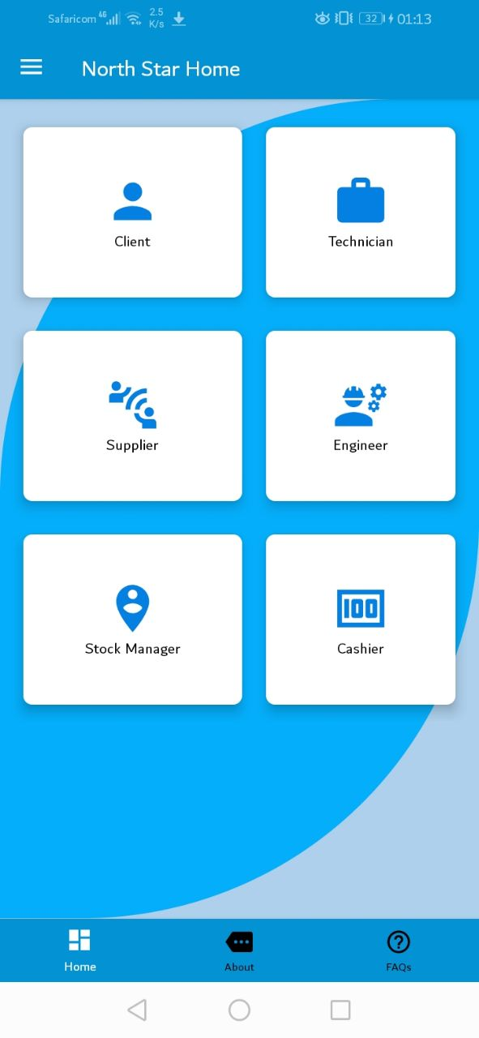

### **4.1.1 Admin Interface**

This is the interface where the admin is going to use to login and access the system through keying in credentials; email and password.

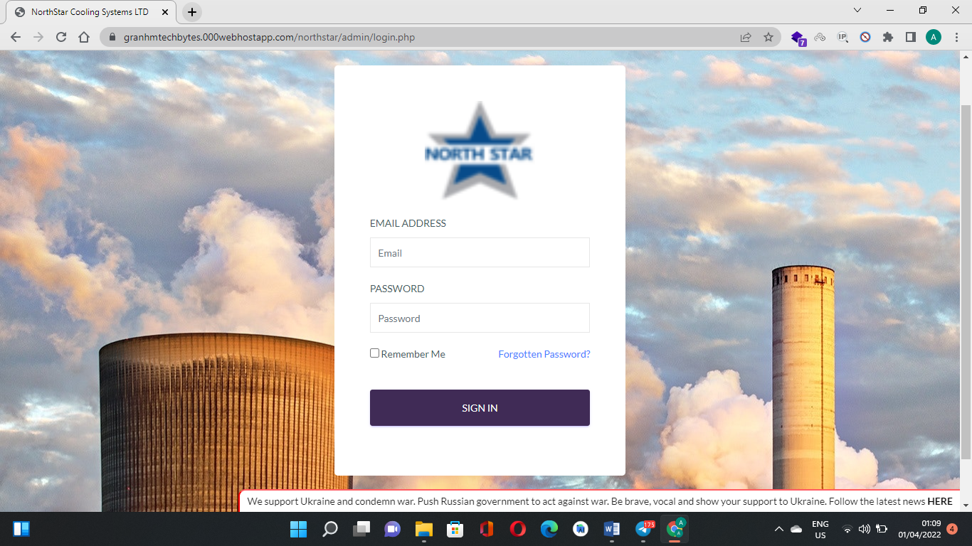

## **4.1.2 Admin dashboard**

This is the first screen the admin is able to see once he logs into the system. The admin is tasked with **activating** and **deactivating** users. It also has the search area for searching a specific level of data required by the admin and a **marquee** to display company information.

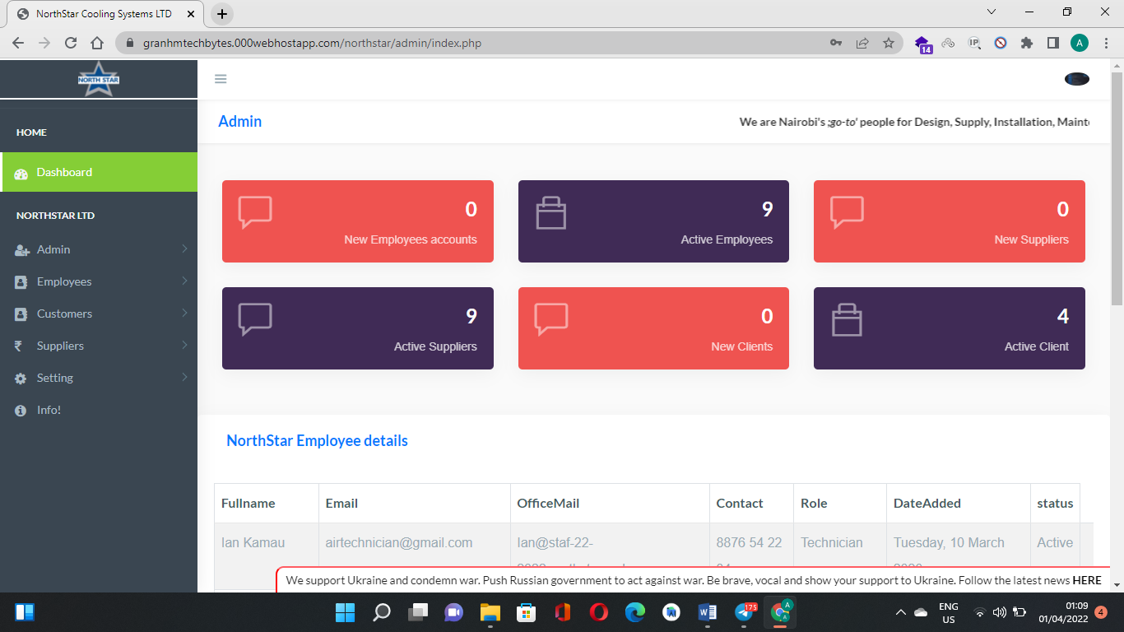

This is an example of admin functions of managing users where we have **pending**, **approved** and even **rejected** users’ statuses.

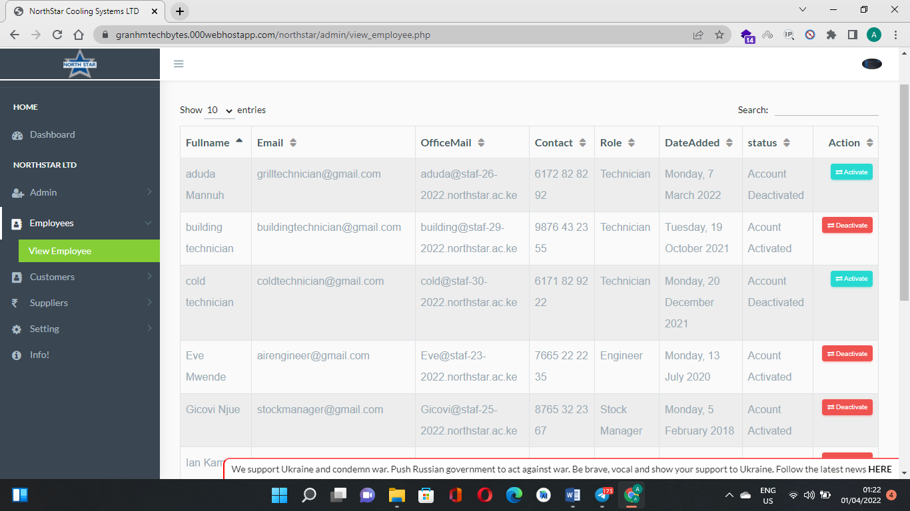

## **4.2 User module**

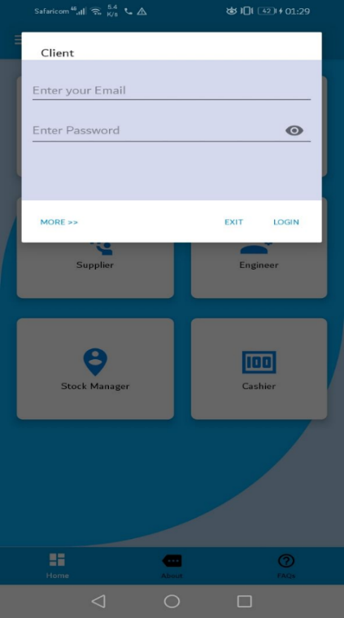This includes the user registration, login and forgot password account interface.

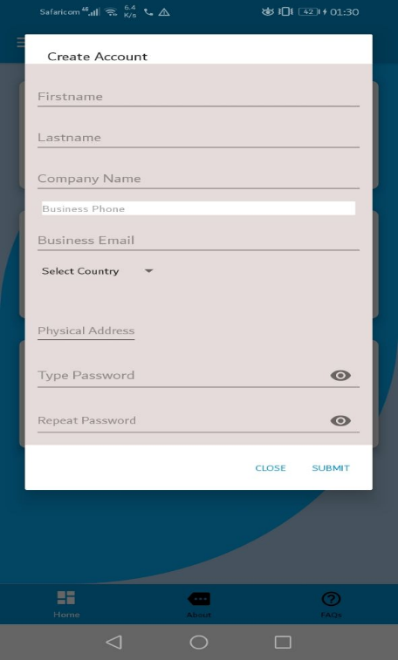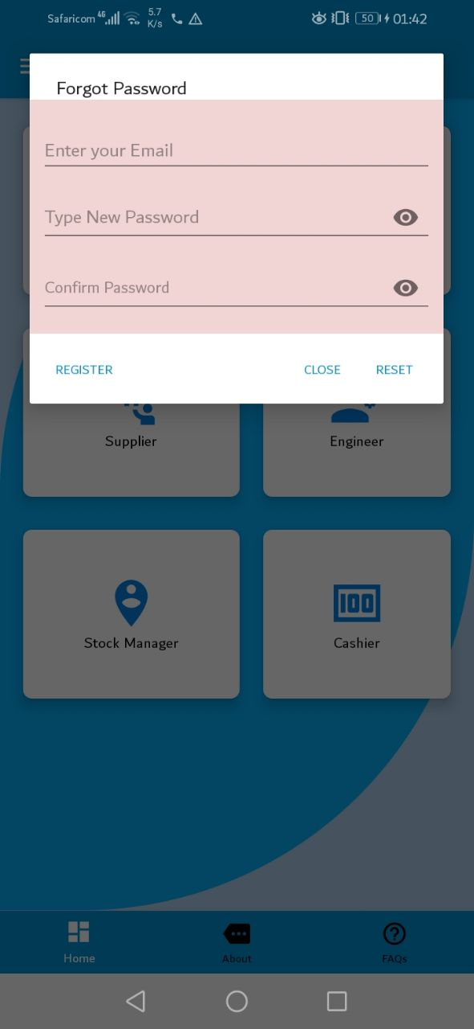

### **4.2.1 Client interface**

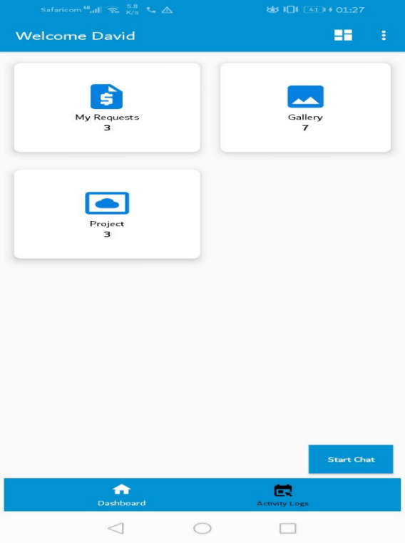This fragment contains the cards to all the tasks the client is allowed to perform once logged into the system; accessing the gallery for both awards and possible projects that can be done, completed projects, requesting and making payments for projects, printing reports and a chat system to communicate to the employees.

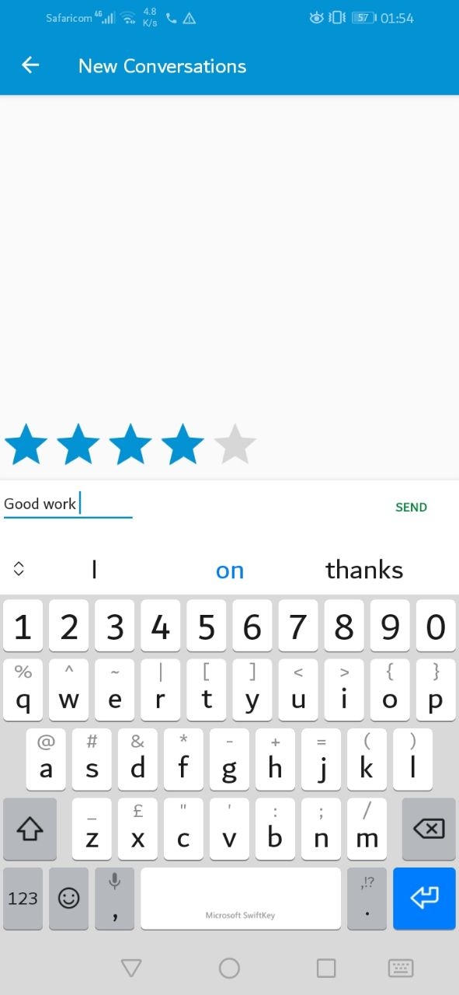

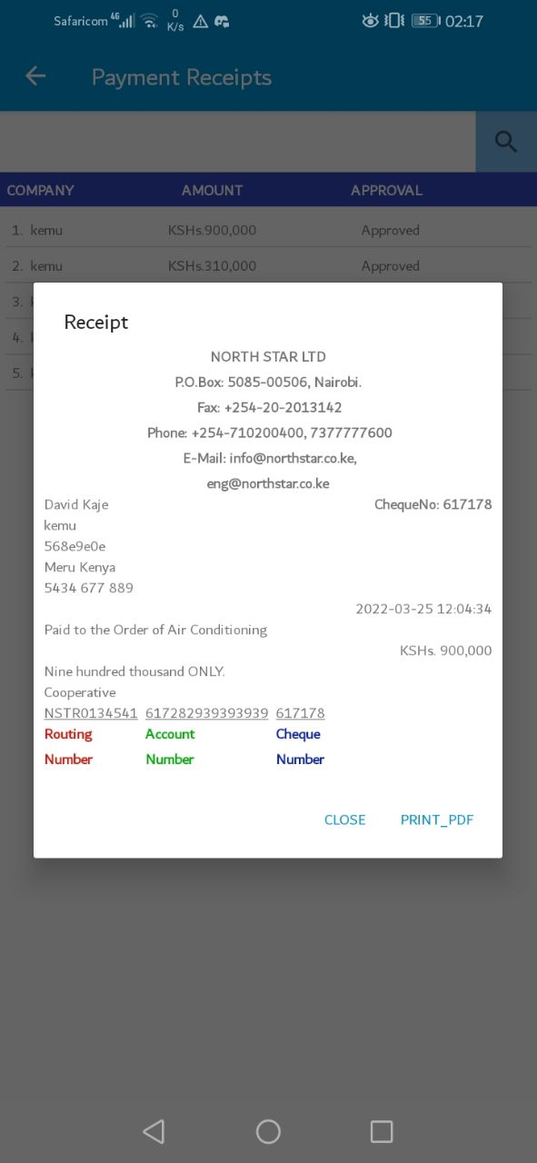 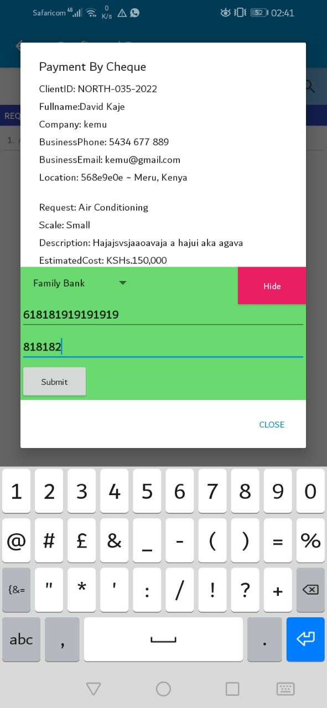

### **4.2.2 Supplier Interface**

This fragment contains the links to the tasks the supplier is allowed to perform once logged into the system; viewing requested orders from the stock manager, delivering the ordered goods, and receiving and downloading the payment reports

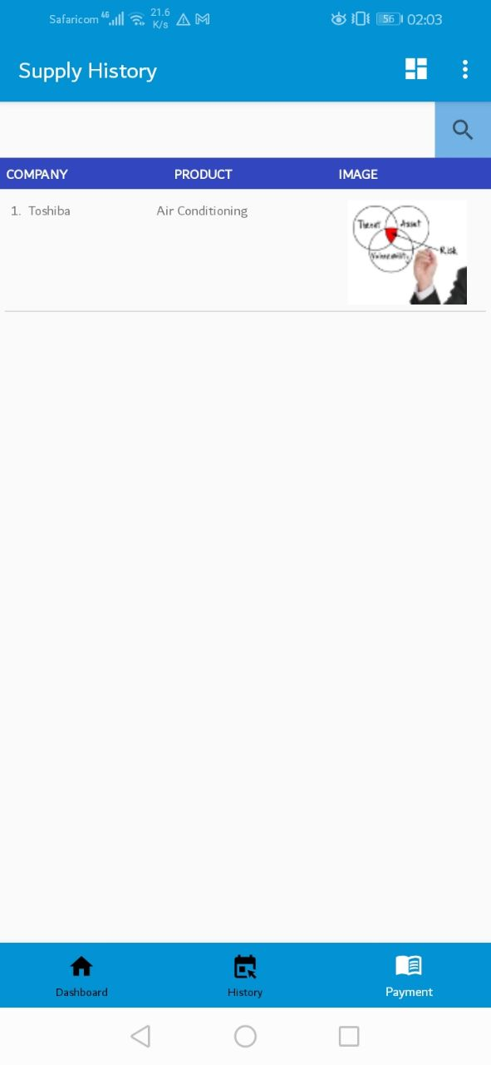 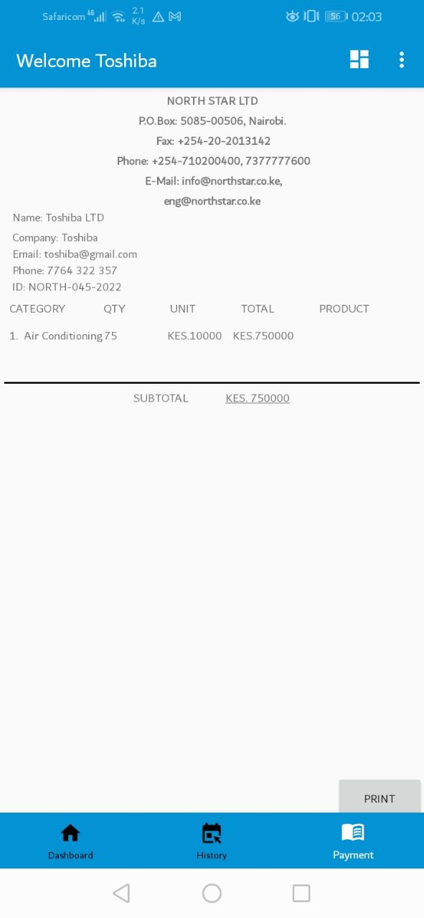

### **4.2.3 Cashier Interface**

The cashier fragment contains links that allow the cashier to approve or reject client’s payments, disburse suppliers’ payment and generate payment reports.

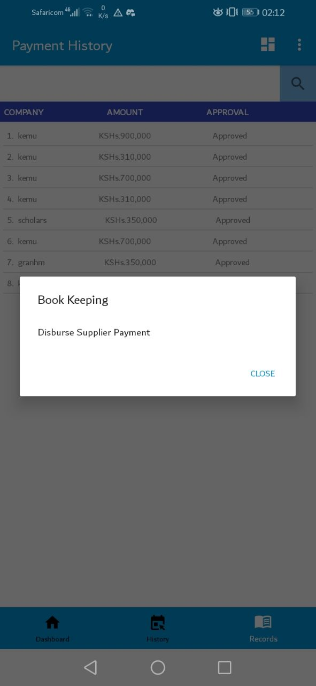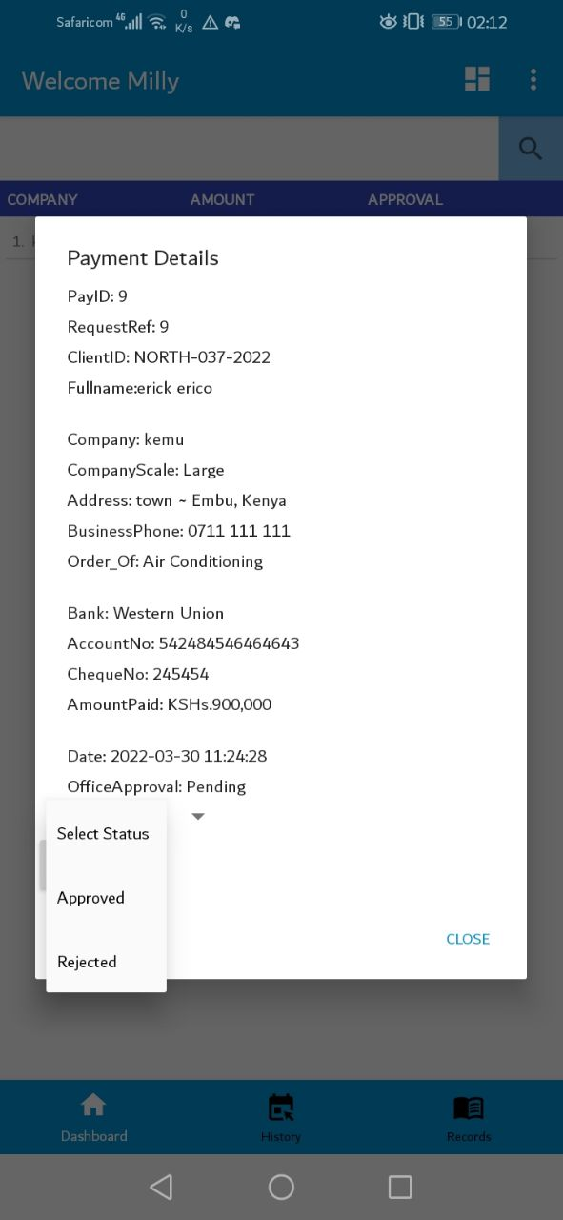

### **4.2.3 Stock manager Interface**

This fragment contains links that allow the stock manager to; make orders to the supplier, view and approve the supplied products, approve customers’ orders, assign an engineer to ongoing projects, publish completed projects to the clients, upload and update the awards and projects’ gallery.

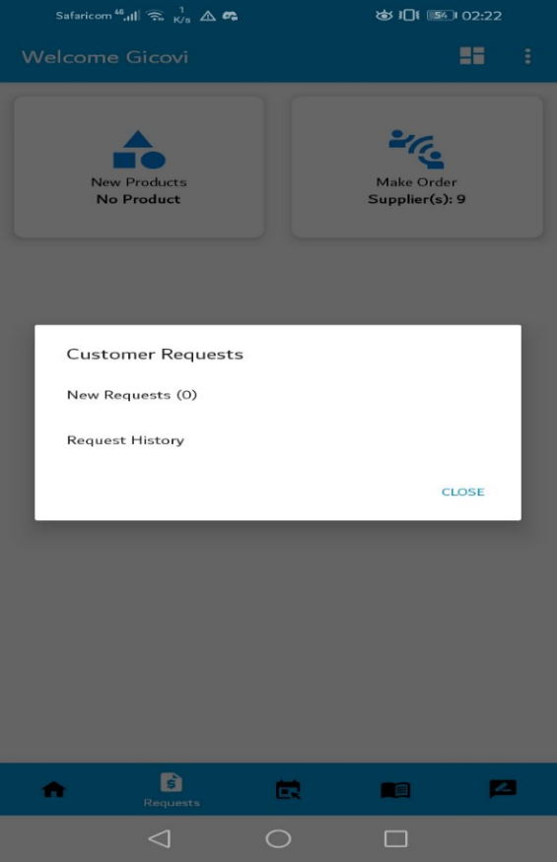 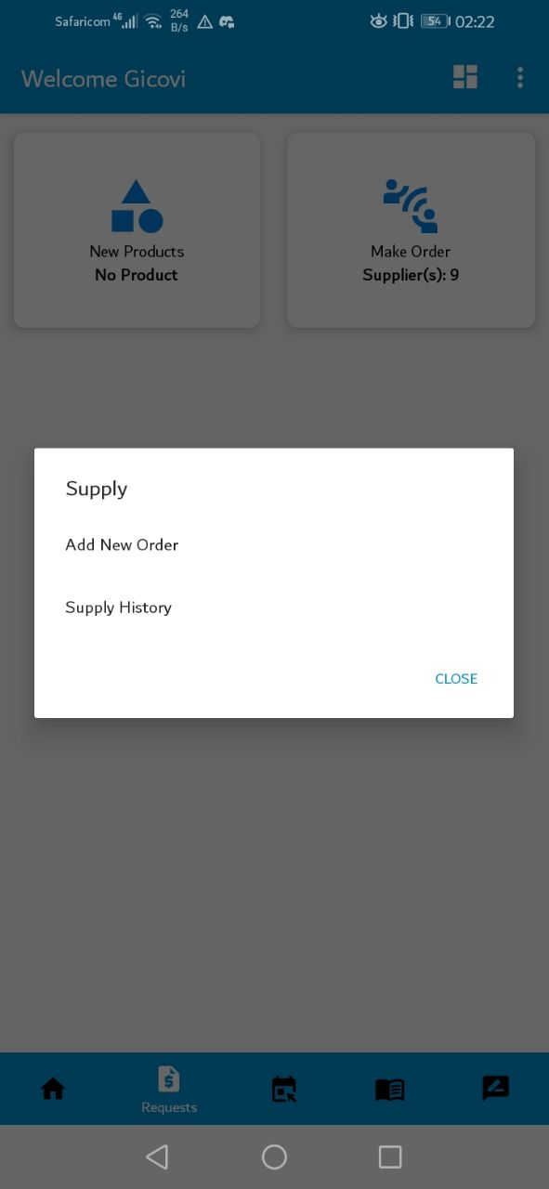

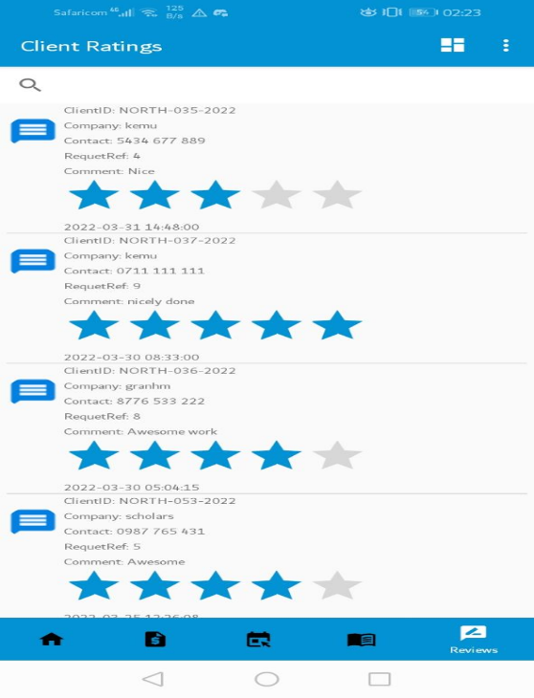

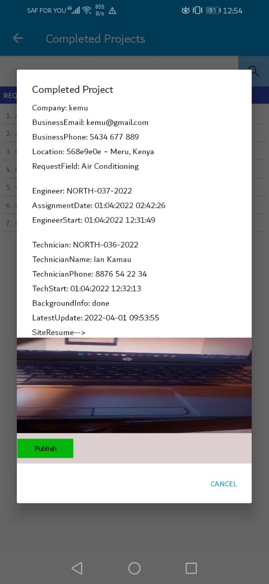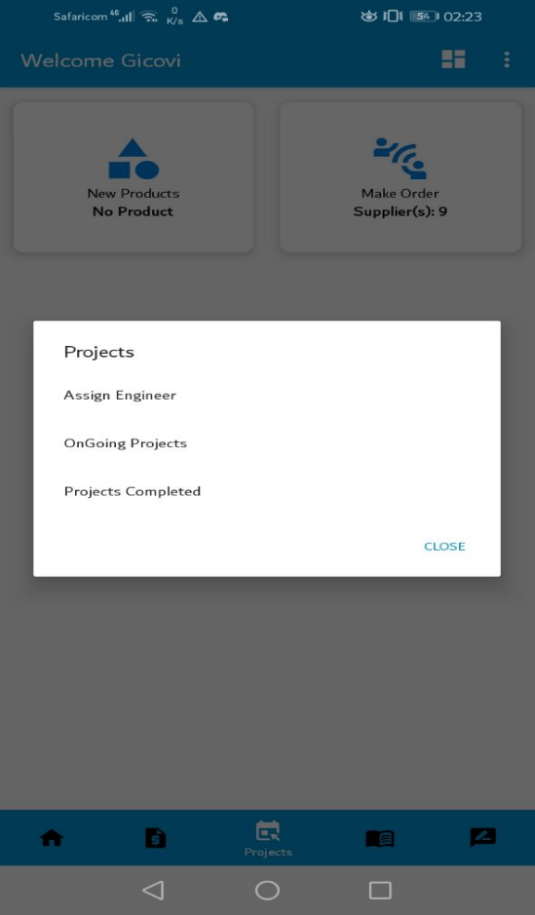 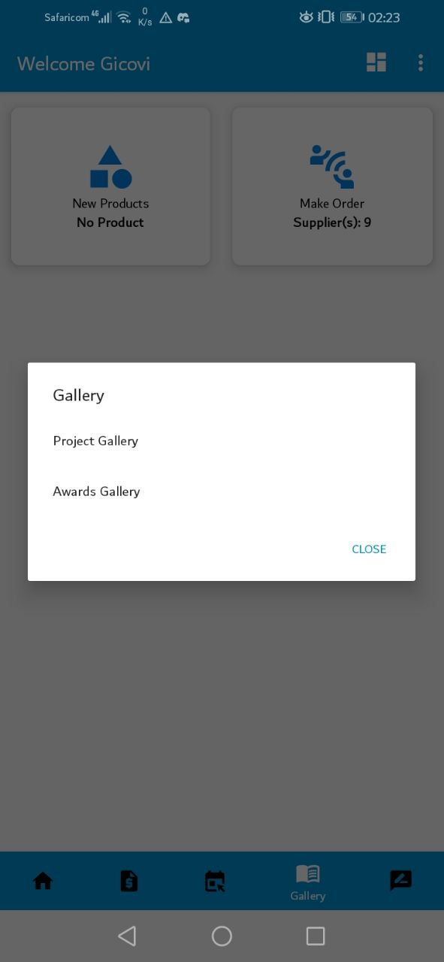

### **4.2.3 Engineer Interface**

This fragment contains links that allow the engineer to; confirm assigned projects, estimate the number of raw materials, assign technician to the project and complete projects back to the stock manager.

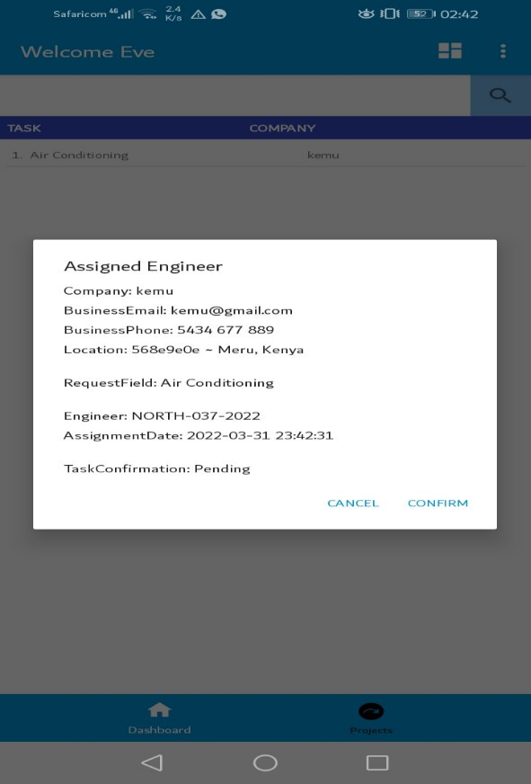 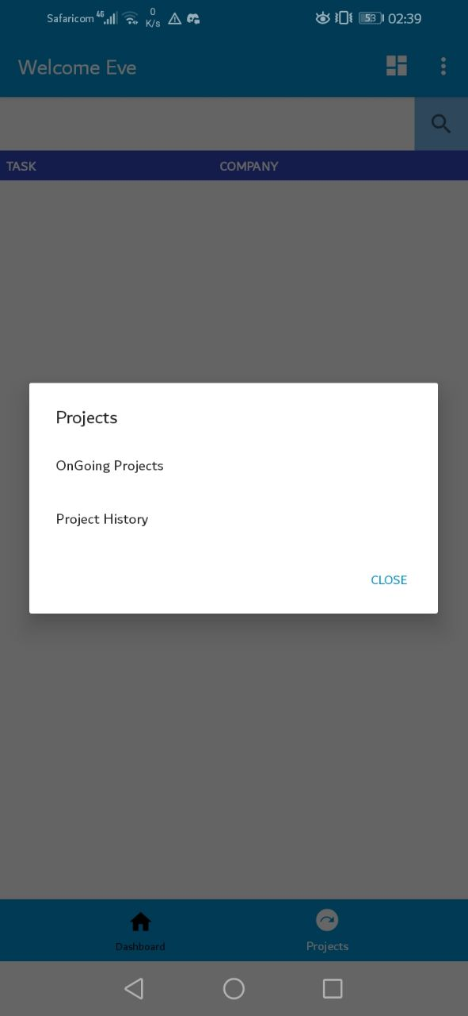

## 

### **4.2.4 Technician Interface**

This fragment contains links that allow the technician to; confirm assigned projects, give a detailed report of the project to the engineer and closes the project once completed back to the engineer.

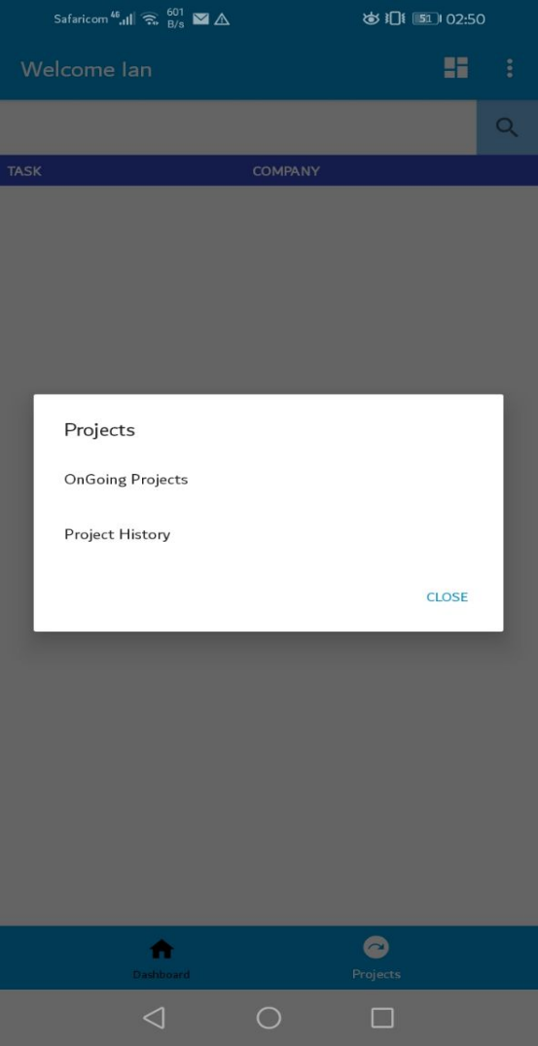 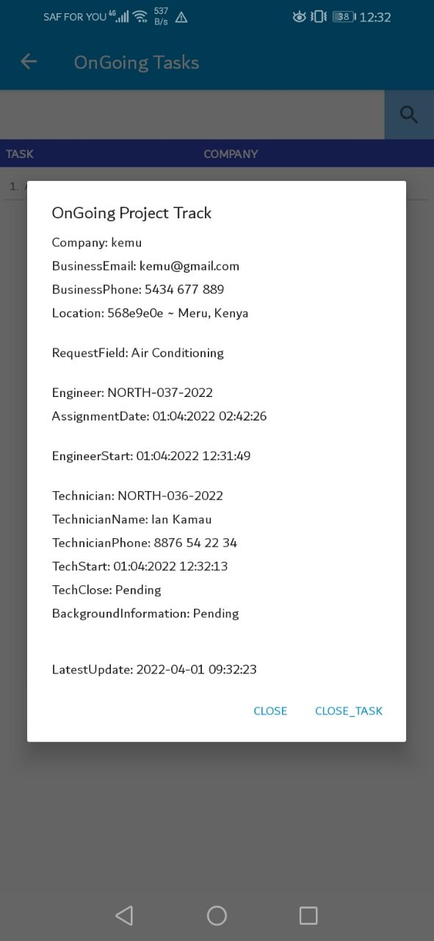  
 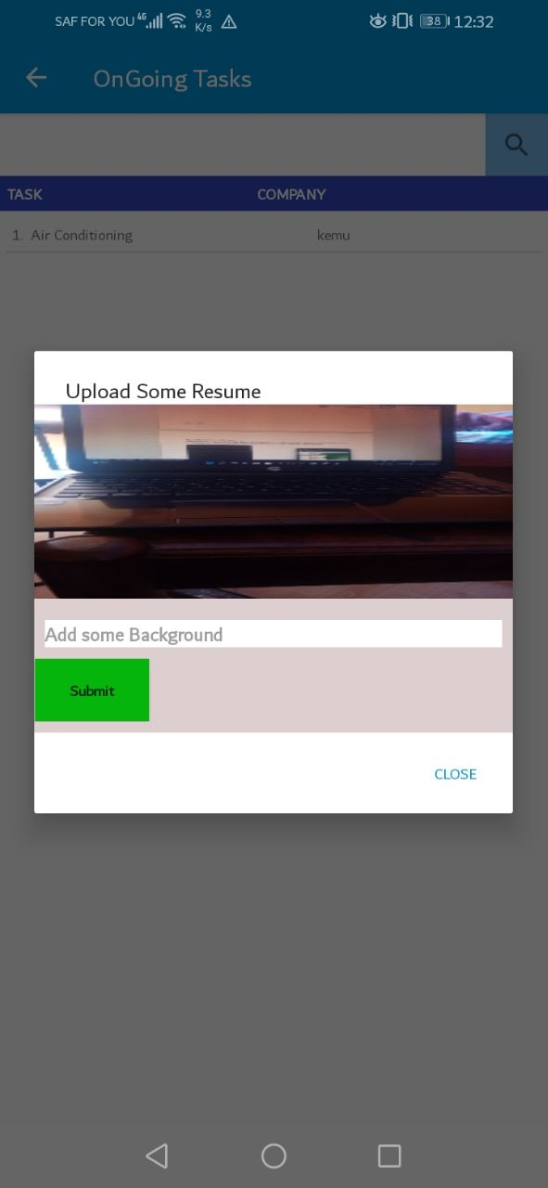

# **4.3 Report module**

This module generates the reports on sales and supplies between the client to the organization and the organization to the supplier

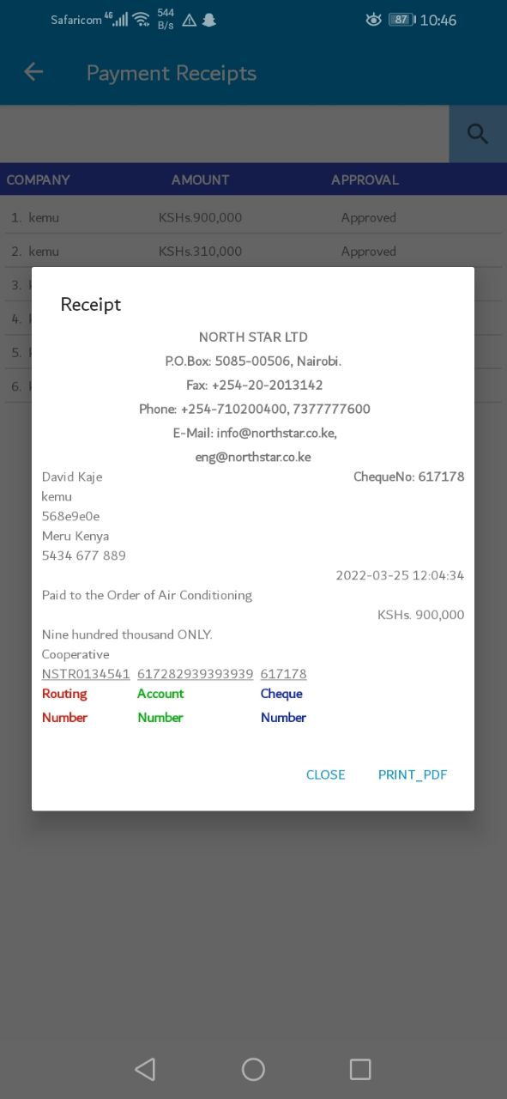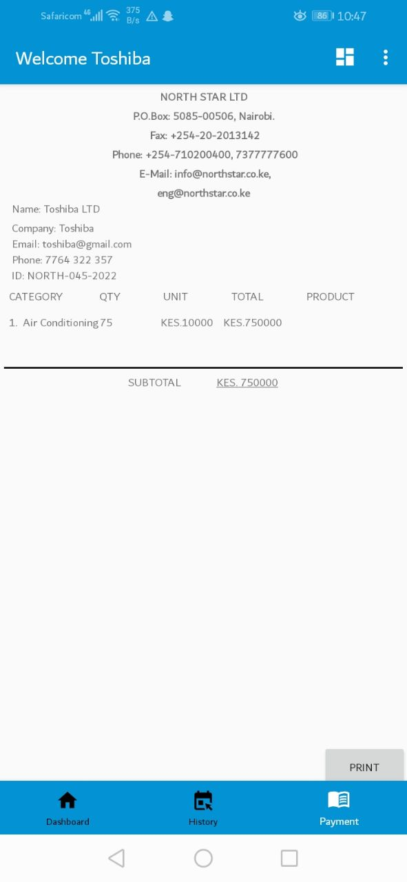

# **4.4 Help and FAQs module**

This module contains the guidelines on how to use the system for various users with frequently asked questions by the users. This module can be accessed by every user on the system when they immediately launch the nortthstar app

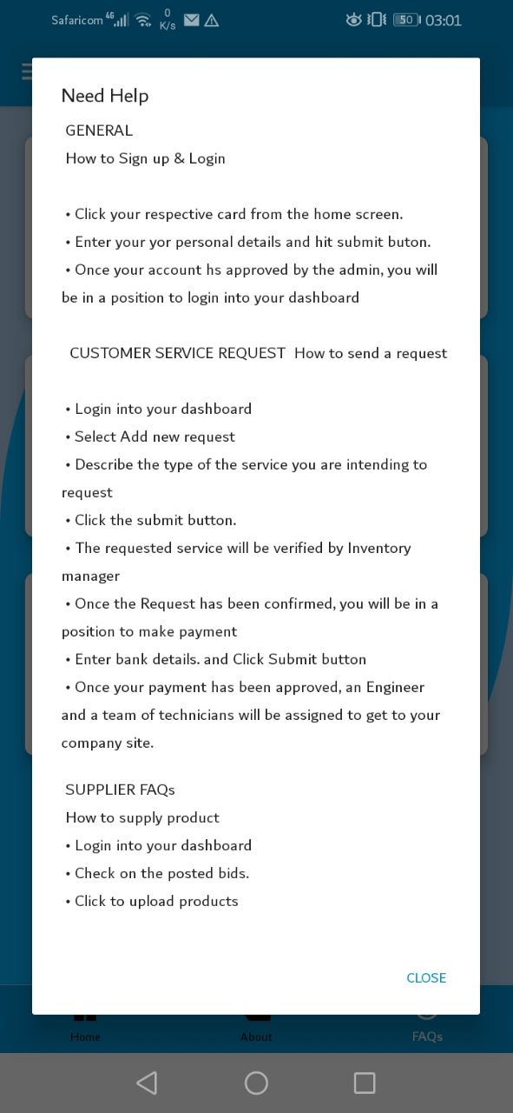

# **4.5 About us module**

This module gives a description and location of the company.

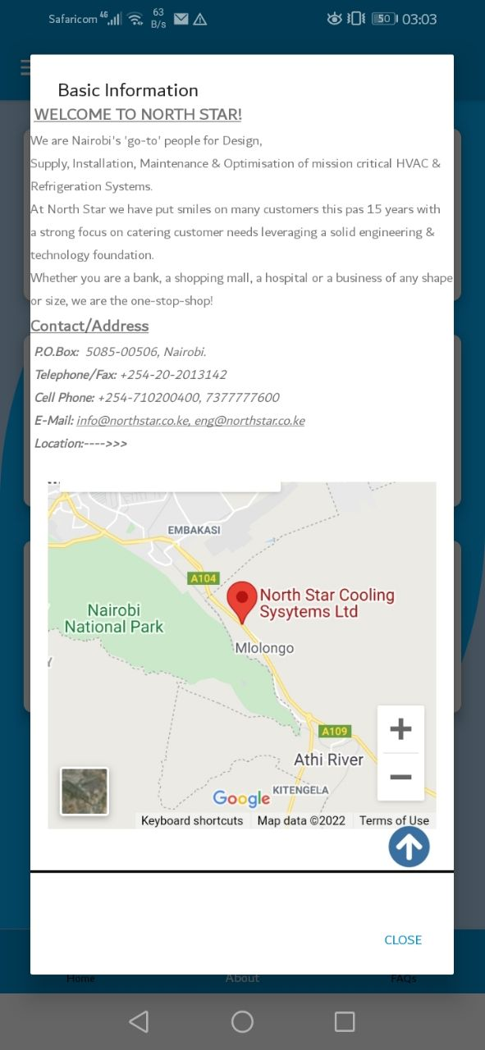

# **4.6 Database module**

This is where all the system data are stored and can be extracted at any time through the execution of a various ranges of activities from both the web panel and android application.

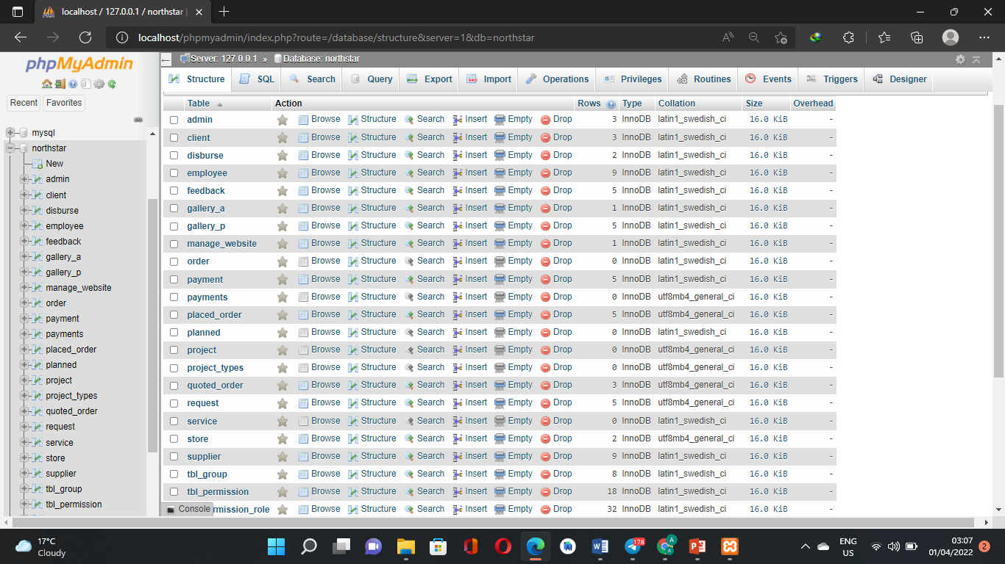

# **5.0 Conclusion and Recommendations**

## **5.1 Conclusions**

The project was done by conducting a study on the current North Star cooling systems LTD ordering and execution processes. This was done through observation, direct communication and researching activities that are taken during the ordering processes. Knowledge on mobile application with **java** and **xml** development and website development strategy was used to develop the system.

Therefore, developing a project of this kind through coding I have not only got an experience of software development but I have also had a chance of implementing security features through secure login sessions and correct validations.

## **5.2 Recommendation**

Having gone through the project development phases, I recommend that the system should be deployed and be used by the organization since it meets the operational feasibility.

Maintenance and upgrading can be done by other developers to ensure that the system runs effectively and up to the set standards of the organization and government requirements.

# References

* Kumar, N., (2018). E-Commerce: An Analysis of Present Status, Challenges and Opportunities. International Journal of Management Studies. (5), 2(3), 90-95.
* Seth, A., Wadhawan, N., (2016). Technology Revolutionizing Retail Practices in Digital Era. International Journal of Recent Research Aspects, 60-62. 5. Shettar, M., (2016). Emerging
* Jamsheer, K. (2019). Impact of E-Commerce on Society: Advantages and Disadvantages. Available: <https://acowebs.com/impact-ecommerce-society/>.
* Georgeakopoulos, D., & Jayaraman, P. P. (2016). Internet of things: From internet scale sensing to smart services. *Computing, 98*(10), 1041–1058.
* Gao, F. and Su, X. (2017), “Omni channel retail operations with buy-online-and-pick-up-in-store”, Management Science, Vol. 63 No. 8, pp. 2478-2492.
* (Searchcio, 2019). E-commerce definition. What is ecommerce? Available: https://ecommerceplatforms.com/glossary/ecommerce